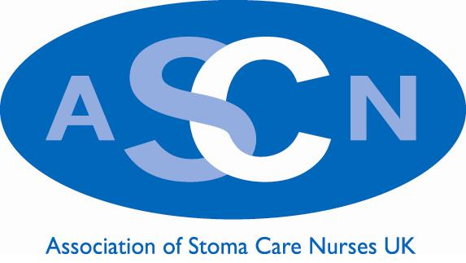

Stoma Care Nurse of the Year 2023

Do you know a Stoma Care Nurse who has been outstanding, and has excelled over the last 12 months, and deserves to be honoured by his/her colleagues?

This is an opportunity for you to personally nominate the Stoma Care Nurse you feel has performed above and beyond the call of duty and deserves recognition from ASCN UK.

How have they:
- Demonstrated a significant contribution to the stoma care specialism
- Contributed to enhancing/evolving the evidence base within stoma care nursing – participated in research/audit/publication or National presentations
- Raised the profile of the specialism within your area
- Developed practice to improve and evolve patient experience
- Demonstrated a pro-active approach to share best practice and enhance patient experience

Please send your nomination form directly to the Chair of ASCN UK chair@ascnukmail.com and ASCN UK Secretariat ascnuk@in-conference.org.uk along with 500 words advising the committee why you think this person should be chosen and how they have fulfilled the above criteria. Please attach any additional information as supportive evidence to your nomination

The winner will be judged and chosen by the ASCN UK committee prior to the ASCN UK conference. We are very grateful that this prestigious Award is kindly sponsored by SALTS, but SALTS have no influence or involvement in the final decision of the ASCN UK committee.

The announcement of the successful winner will be at the 2023 conference.

The deadline for submissions is Friday 22nd September 2023

Thank You

Nomination Form
Stoma Care Nurse of the Year 2023

I would like to Nominate…..……………………….…For the Stoma Care Nurse of the Year 2023

Who works at… ………………………………

Department:…… ………………………………………

Job Title…… ………………………………………

Hospital… …………………………………………,

I would like to nominate ..........because (please include your 500 words and attach any additional information to support this nomination)

How have they:
- Demonstrated a significant contribution to the stoma care specialism
- Contributed to enhancing/evolving the evidence base within stoma care nursing – participated in research/audit/publication or National presentations
- Raised the profile of the specialism within your area
- Developed practice to improve and evolve patient experience
- Demonstrated a pro-active approach to share best practice and enhance patient experience

Your Name… ……………………………………………

Hospital… ………………………………….

Telephone Number: Work………………………………………………….

Telephone Number: Mobile………………………………………………….

Email Address…… ……………………………………………………………..

Please email this nomination to
Andrew Bird (Chair ASCN UK) email: chair@ascnukmail.com
ASCN UK Secretariat email: ascnuk@in-conference.org.uk

